**Using FindWithTag()**

**Objective:** In this lesson students will learn how to programmatically add new VFX GameObject’s into the Swan At Runtime GameObject.

1. Delete the 4 Enemy placeholders in the front. They’ve served their purpose.
2. Add New Enemy prefab in path
3. Make sure enemy has Enemy.cs script and VFX for Death and Hit
4. Now we don’t want to manually add the Swan At Runtime GameObject as the Parent to every instance of an Enemy and we can’t set this up in the PreFab because we need the Instance of the VFX to be parented and not ALL VFX. Long story short we want this done in the code.
5. Click on Spawn At Runtime GameObject in the hierarchy
6. Create a tag called SpawnAtRuntime and assign it to the GameObject
   1. Click on the **Add Tag** then the **Plus** symbol to create a new tag

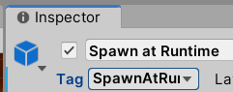

1. In your Start method after the scoreboard assignment I’m going to look for this newly created Tag and assign it to the parent GameObject

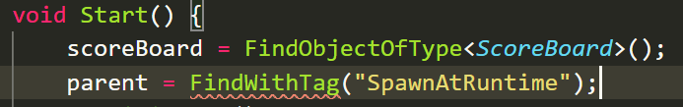

1. Find your [SerializeField] Transform parent line and lets change it. We’re going to bring it up one level higher. So instead of JUST the transform module we’re going to access the whole GameObject. We’re also going to get ride of the [SerializeField]

|  |  |
| --- | --- |
| **Before**  **(line 8)** |  |
| **After (moved to line 12)** |  |

1. Lets change the FindWithTag method to include the GameObject



1. Find the **processHit** and **killEnemy** methods
2. There’s a red squiggly under the **parent** because it doesn’t understand what that tit. We need to access its TRANSFORM module. So add **.Transform** to **both**



Now I hate how this line looks. Because it looks like we’re assigning the member variable parent (the one on the right of the equal sign) to the parent that we have that’s a property of transform that is a part of the VFX (the one on the left of the equal sign)

1. Scroll to line 12 and rename the **parent** variable to **parentGameObject** (remember to use F2 to rename all locations)



1. Go test your changes.